

**Air Pollutants – Spatial Patterns, Correlations and Predictive Modelling**

**Shivani Korupoju**

**Nikhitha Vuppalapati**

**Nikhil Kavali**

**University of North Texas**

**Toulouse Graduate School**

**ADTA 5940 – Capstone**

**Dr. Denise Philpot**

**Table of Contents**

**1.** **Introduction** 3

**1.1** **Background** 4

**1.2** **Objectives** 5

**1.3** **Scope of the Review** 7

**2. Literature Review** 9

**2.2 Spatial Patterns of Air Pollutants** 11

**2.3 Correlations Between Air Quality and Environmental Factors** 14

**2.4 Predictive Modelling Approaches** 17

**2.5 Current State** 19

**2.6 Future Directions and Emerging Trends** 22

**3. Research Methodology** 23

**3.1 Data Collection** 23

**3.2 Dataset** 26

**3.3 Data Pre-processing** 29

**3.4 Spatial Analysis Techniques** 33

**3.5 Predictive Modelling Methods** 36

**4. Results and Findings** 38

**4.1 Spatial Patterns of Air Pollutants** 38

**4.2 Correlation Analysis** 39

**4.3 Predictive Modelling Results** 39

**5. Discussion** 40

**5.1 Interpretation of Results:** 40

**5.2 Implications for Environmental Policy:** 43

**5.3 Limitations and Future Research Directions** 44

**Limitations:** 44

**Future Research Directions:** 45

**6. Conclusion** 46

**Summary of Key Findings:** 46

**Recommendations for Future Research:** 47

**References** 49

# **Introduction**

Air pollution poses a vast threat to public health and the surroundings, with unfavourable results starting from respiration sicknesses to ecological imbalances. Understanding the spatial patterns, correlations, and predictive modelling of air pollutants is important for powerful environmental control and coverage-making. This scholarly overview goals to explore the modern-day state of research on this subject, specialising in studies conducted throughout the United States. The assessment will synthesise existing literature on spatial patterns, correlations, and predictive modelling of air pollutants, offering insights into methodologies, findings, and boundaries of previous studies. By inspecting research articles, reports, and scholarly guides from peer-reviewed journals, authorities, companies, and academic establishments, this overview seeks to identify gaps in understanding and areas for destiny research. Additionally, it aims to offer insights which could inform environmental coverage-making and make contributions to the development of sustainable techniques for air quality management inside the United States.

In the literature, another key finding is the need to apply advanced statistical and geospatial modeling of spatial variation of air pollutants. For example, studies have used land-use regression, kriging, and machine learning to capture the complex relationships between air pollution and indicators of sources such as traffic, land use, and meteorology. These approaches have been successful in the prediction of fine scale air pollution exposures, which is critical for estimating population health burden. Finally, the literature analyzed correlations between different air pollutants. Multivariate statistical techniques include principal component and cluster analysis, which has been applied to identify air pollutants and their sources of emission. The identification of the causing factors could help develop targeted interventions which promise tangible impacts.

The review also emphasizes the importance of further monitoring and data collection to accompany air quality modeling and policymaking. Several reports have documented the possibility and value of combining mobile monitoring platforms and satellite data to overcome challenges due to the spatial and temporal variability of air pollution. By combining different types of data, it is possible to increase the speed and reliability of air pollution assessments.

## **Background**

Air pollutants have emerged as an important environmental and public health difficulty globally, with profound implications for human well-being and ecological sustainability. The speedy industrialization, urbanisation, and increase of transportation systems have considerably contributed to the growth in air pollutant emissions, leading to extreme environmental degradation and destructive health consequences. In the USA, air pollutants have been a longstanding challenge, dating again to the commercial revolution. The use of a's transition to a greater industrialised and urbanised society has caused the discharge of numerous pollutions into the ecosystem, consisting of particulate be counted, nitrogen oxides, sulphur dioxide, unstable natural compounds, and heavy metals. These pollutions originate from numerous sources such as automobile emissions, industrial activities, strength technology, agricultural practices, and residential combustion. The negative effects of air pollution on public health are well-documented, with research linking exposure to air pollutants to breathing illnesses, cardiovascular issues, negative delivery outcomes, and premature mortality. Vulnerable populations, which includes kids, the aged, and people with pre-current health conditions, are particularly liable to the health effects of air pollution.

In addition to its effect on human fitness, air pollution additionally poses big environmental challenges, which include acid deposition, eutrophication, ozone depletion, and climate change. Particulate count and other pollution, can settle on surfaces, contaminating soils and waters. On the other hand, nitrogen oxides and sulphur dioxide could be components for the formation of acid rains, which influence ecosystems and biodiversity. It is now increasingly recognized that the complex nature of air pollutants and multifaceted influence require comprehensive research and analysis in order to decipher spatial patterns, correlations, and predictive modelling. Description of the resources, geographical distribution, and dynamics of the air pollutants would also assist researchers and policy makers in targeting their interventions and mitigation strategies for enhancing air quality and protecting public health and the environment. Against this background, the paper in question is going to probe air pollutants within the territorial boundary of the United States and present an historical review regarding its historic development, the sources and determinants of regulation, regulatory mechanism, and relevant health and environmental impact (Yanosky et al., 2014). This will mean the contextual importance of the spatial styles, correlations, and predictive modelling in further understanding of the air pollution dynamics, informing evidence-based decisions, and policy formulation.

## **Objectives**

The aims of the present academic assessment are many in number, since they provide a detailed account of the spatial style, connections, and predictive modelling of air pollution through the US.

1. To Explore Spatial Patterns: One of the primary goals is to have a look at the spatial distribution of air pollution across special geographic regions within the United States. By analysing spatial statistics from monitoring stations and satellite tv for pc observations, we aim to identify hotspots of pollution awareness and investigate the spatial variability of pollutants which include particulate depend, ozone, nitrogen dioxide, and sulphur dioxide.
2. To Investigate Correlations: Another objective is to investigate the correlations between numerous air pollutants and their underlying drivers. By inspecting ancient facts and undertaking statistical analyses, we are trying to find to discover relationships between pollutant concentrations and elements together with commercial interest, vehicular emissions, population density, land use styles, and meteorological conditions. Understanding these correlations can offer insights into the assets and dynamics of air pollution.
3. To Develop Predictive Models: A key objective is to expand predictive models to forecast air pollutant concentrations and expect future tendencies. By leveraging device studying algorithms, which includes regression, random forests, and neural networks, we aim to build models which could appropriately expect pollutant degrees primarily based on ancient statistics and environmental variables. These predictive models can assist policymakers and stakeholders make knowledgeable decisions and enforce centred interventions to mitigate air pollution.
4. To Assess Health and Environmental Impacts: Additionally, we intend to assess the fitness and environmental effects of air pollutants using epidemiological and ecological studies. By studying fitness consequences, inclusive of respiratory illnesses, cardiovascular issues, and mortality fees, we are seeking to quantify the load of air pollution on public fitness. Furthermore, we aim to assess the ecological results of air pollution on ecosystems, biodiversity, and surrounding services.
5. To Inform Policy and Decision-Making: Finally, the objective is to translate study’s findings into actionable insights for policymakers, regulators, and other stakeholders. By synthesising medical evidence and great practices, we aim to offer hints for coverage formulation, regulatory enforcement, urban planning, transportation control, and emission discount strategies. Ultimately, our aim is to contribute to the development of proof-primarily based guidelines and interventions that sell easy air, public fitness, and environmental sustainability.

## **Scope of the Review**

The scope of this scholarly overview contains a huge range of subjects related to the spatial styles, correlations, and predictive modelling of air pollution across America.

1. Geographic Coverage: The overview will focus on research carried out in the geographical limitations of the USA, together with urban, suburban, rural, and industrial areas. By inspecting studies performed across extraordinary areas, climates, and ecosystems, we intend to capture the diverse spatial styles and drivers of air pollutants.
2. Temporal Considerations: We will explore temporal developments in air pollutant concentrations over various time scales, starting from short-term fluctuations to long-time period trends. By analysing historical facts spanning several years or decades, we goal to perceive temporal styles, seasonal variations, and developments in pollutant levels, in addition to the impact of climate change and regulatory interventions on air first-rate.
3. Pollutants of Interest: The assessment will cognizance on a huge range of air pollutants, including criteria pollutants such as particulate remember (PM2.Five and PM10), ozone (O3), nitrogen dioxide (NO2), sulphur dioxide (SO2), carbon monoxide (CO), and volatile organic compounds (VOCs). Additionally, we are able to explore emerging pollutants, risky air pollutants (HAPs), and greenhouse gases (GHGs) that pose dangers to human health and the surroundings.
4. Methodological Approaches: We will observe numerous methodological approaches utilised in air best studies, along with far off sensing techniques, ground-based monitoring networks, air satisfactory modelling, statistical evaluation, and gadget gaining knowledge of algorithms. By reviewing extraordinary methodologies and their programs, we intend to assess the strengths, obstacles, and fine practices in air high-quality studies.
5. Interdisciplinary Perspectives: The overview will contain interdisciplinary perspectives from fields including environmental science, atmospheric chemistry, epidemiology, urban planning, public health, and coverage evaluation. By integrating insights from numerous disciplines, we aim to offer a holistic knowledge of the complex interactions between air pollutants, human fitness, ecosystems, and society.
6. Policy and Management Implications: Finally, the overview will discuss the coverage implications and control techniques bobbing up from air satisfactory research. By synthesising medical evidence and policy guidelines, we intend to inform decision-makers, regulators, city planners, and stakeholders approximately effective measures for air pleasant control, pollution manipulation, and sustainable development.

The scope of this evaluation is complete and interdisciplinary, aiming to provide precious insights into the spatial styles, correlations, and predictive modelling of air pollutants across the USA and their implications for public fitness, the environment, and policymaking.

# **2. Literature Review**

This scholarly evaluation embarks on a journey to discover the spatial styles, correlations, and predictive modelling of air pollution throughout the US, leveraging facts from the EPA and other applicable assets. By delving into the intricacies of air pollution dynamics, this examination seeks to discover treasured insights into pollutant tendencies, distributional patterns, and the underlying factors driving versions in air. Through rigorous evaluation and interpretation of information, we aim to contribute to the growing body of know-how on air pollution and tell proof-primarily based choice-making geared toward mitigating its destructive outcomes. As we embark in this undertaking, it's miles vital to understand the multifaceted nature of air pollution and its always-reaching implications for environmental sustainability, public fitness, and social fairness. By dropping light on the spatial, temporal, and meteorological dimensions of air, we hope to pave the way for informed interventions that sell cleaner air and healthier communities throughout the US and past (Hoek, 2008).

**2.1 Trends in Air Pollution Research**

Air pollution studies have evolved considerably through the years, driven via improvements in generation, increased attention to environmental problems, and developing issues about public fitness effects. Recent developments in air pollutants research have focused on several key regions:

1. Health Effects: One fundamental style is the exploration of the health consequences of air pollution on human populations. Epidemiological research have provided compelling evidence linking exposure to air pollutants together with particulate rely (PM), ozone (O3), nitrogen dioxide (NO2), and sulphur dioxide (SO2) to a huge variety of destructive health outcomes, together with respiration diseases, cardiovascular disorders, and even premature mortality. Researchers have employed state-of-the-art statistical strategies and huge-scale epidemiological datasets to quantify the load of ailment because of air pollutants and confirm the effectiveness of regulatory interventions.
2. Spatial and Temporal Variability: Another crucial fashion is the characterization of spatial and temporal variability in air pollutant concentrations. Researchers have carried out advanced tracking networks, satellite faraway sensing, and air nice modelling equipment to research spatial patterns, hotspots, and tendencies in air pollution stages across distinctive regions and seasons. Understanding the spatial distribution of air pollution is important for identifying assets of pollution, assessing publicity disparities among prone populations, and designing focused mitigation techniques.
3. Sources and Emissions: Studies have an increasing number of targets on figuring out properties of air pollutants and quantifying emissions from several anthropogenic and natural sources. Source apportionment techniques, together with receptor modelling and chemical fingerprinting, had been hired to attribute pollutants resources and estimate their contributions to ambient air pleasantness. Additionally, advances in emission inventories, mobile monitoring era, and some distance flung sensing structures have facilitated the monitoring of pollutant assets and the assessment of emission tendencies over time.
4. Climate Change Interactions: Recent research has moreover explored the complicated interactions amongst air pollutants and weather alternate. Air pollutants together with black carbon (BC), methane (CH4), and carbon dioxide (CO2) contribute to global warming and regulate atmospheric dynamics, at the same time as climate change impacts the formation, delivery, and chemical reactions of air pollution. Understanding those interactions is critical for developing incorporated techniques to mitigate both air pollution and climate exchange, in addition to assessing their combined influences on human fitness, ecosystems, and the economic gadget.

In summary, trends in air pollutants research mirror a growing popularity of the multifaceted nature of air quality troubles and the want for interdisciplinary techniques to cope with them. By investigating health effects, spatial variability, pollutants resources, and climate interactions, researchers are advancing our know-how of air pollution dynamics and informing evidence-based totally hints and interventions to guard public health and the surroundings (Laden, 2009).

## **2.2 Spatial Patterns of Air Pollutants**

The spatial distribution of air pollution is prompted through a complex interplay of emission resources, atmospheric methods, meteorological situations, and geographical capabilities. Understanding spatial styles of air pollution is critical for identifying pollutants resources, assessing publicity risks, and designing effective air first-rate management strategies. Recent research has focused on characterising spatial patterns of air pollution the usage of plenty of strategies and datasets:

1. Monitoring Networks: Ground-based totally tracking networks offer precious facts on spatial versions in air pollutant concentrations at nearby, local, and countrywide scales. These networks usually consist of fixed monitoring stations geared up with sensors for measuring pollutants along with PM2.Five, PM10, NO2, SO2, O3, and CO. By analysing facts from these networks, researchers can perceive spatial hotspots, pollutants gradients, and developments in pollutant stages through the years.
2. Satellite Remote Sensing: Satellite faraway sensing offers a completely unique attitude on spatial patterns of air pollutants by way of offering international insurance and excessive spatial resolution records. Satellites geared up with sensors together with MODIS, AIRS, and OMI can locate and quantify diverse pollutants in the surroundings, along with aerosols, hint gases, and greenhouse gases. Remote sensing records are used to map spatial distributions of pollution, track pollution plumes, and reveal modifications in air pleasant over massive geographic areas.
3. Air Quality Modelling: Air pleasant models simulate the transport, dispersion, and transformation of air pollutants in the environment based on emissions, meteorological information, and chemical reactions. These models, together with CMAQ, CAMx, and WRF-Chem, are used to predict spatial patterns of pollution, determine pollution sources, and evaluate the effectiveness of emission manipulation measures. By integrating monitoring records with version simulations, researchers can improve our expertise of spatial versions in air high-quality and pick out areas of subject.
4. Geospatial Analysis: Geospatial analysis strategies, including GIS mapping, spatial interpolation, and egotistic, are extensively used to research and visualise spatial patterns of air pollution. These techniques permit researchers to create maps, heatmaps, contour plots, and spatial clusters of pollutant concentrations, facilitating the identity of pollutant hotspots, source regions, and exposure disparities. Geospatial evaluation is likewise used to evaluate the spatial correlation among air satisfactory and numerous environmental elements, along with land use, population density, site visitors patterns, and business sports.

Spatial patterns of air pollutants show off widespread variability due to local emissions, meteorological conditions, and geographical elements. By leveraging tracking networks, satellite data, air fine models, and geospatial analysis techniques, researchers can gain insights into the spatial distribution of pollutants, pick out pollutant sources, and tell focused interventions to enhance air first-class and guard public health.

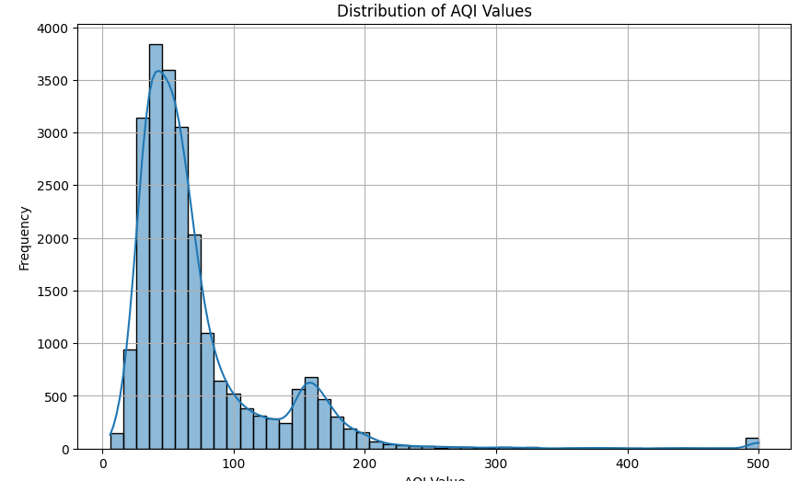

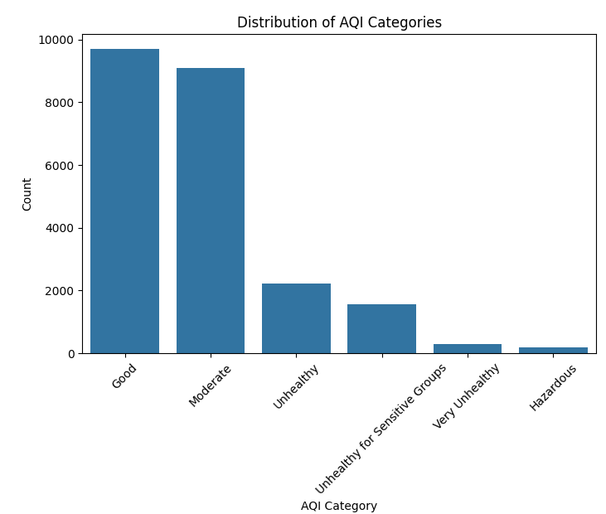

## **2.3 Correlations Between Air Quality and Environmental Factors**

Air niceness is stimulated by a huge variety of environmental elements, consisting of meteorological conditions, geographical functions, land use styles, and human sports. Understanding the correlations between air exceptional and environmental elements is essential for figuring out drivers of air pollution, assessing exposure risks, and developing effective mitigation strategies. Recent studies have investigated diverse environmental factors and their relationships with air excellent:

1. Meteorological Conditions: Meteorological variables such as temperature, humidity, wind pace, and atmospheric stability play an important role in determining the dispersion, shipping, and dilution of air pollutants. Studies have examined correlations between meteorological parameters and pollutant concentrations to understand their impact on exceptional air. For instance, solid atmospheric conditions can result in the buildup of pollutants near the surface, even as strong winds and vertical mixing can disperse pollutants and enhance air fine.
2. Geographical Features: Geographical capabilities along with terrain, elevation, and proximity to water bodies can have an impact on neighbourhood air excellent patterns. Coastal regions can also enjoy higher levels of ozone because of sea breeze circulation, at the same time as mountainous regions can also showcase temperature inversions and stagnant air hundreds that lure pollutants. Studies have explored the correlations among geographical features and air satisfactory indicators to perceive inclined regions and prioritise pollutants control measures.
3. Land Use and Urbanization: Land use styles, urbanisation, and populace density are closely related to air pollutants degrees in urban areas. Industrial sports, transportation emissions, and residential combustion make a contribution to multiplied pollutant concentrations in densely populated areas. Research has examined the relationships among land use kinds, visitors’ quantity, and air high-quality metrics to assess the effect of urbanisation on pollutants ranges. Urban making plans strategies inclusive of green infrastructure, public transit, and land zoning guidelines intention to mitigate pollution impacts and sell sustainable development.
4. Economic Activities: Economic elements such as industrial manufacturing, strength consumption, and financial increase can have an impact on air quality via emissions of pollutants together with particulate count, sulphur dioxide, and nitrogen oxides. Studies have investigated the correlations between financial indicators, pollutant emissions, and air fine metrics to understand the environmental implications of monetary sports. Sustainable improvement dreams aim to decouple financial growth from environmental degradation with the aid of selling cleaner technology, energy efficiency, and pollution control measures (Levy, J. I., 2007).
5. Human Behaviour and Lifestyle: Human behaviour and life-style alternatives additionally play a position in determining air high-quality. Personal transportation, household heating, and recreational activities can make a contribution to emissions of pollutants such as carbon monoxide, unstable organic compounds, and air toxics. Research has explored correlations among human behaviours, pollutant resources, and exposure styles to discover possibilities for behavioural interventions and public cognizance campaigns. Education tasks, behaviour trade programs, and regulatory measures aim to promote sustainable practices and reduce personal and network-stage contributions to air pollution.

Correlations between air quality and environmental elements are complex and multifaceted, reflecting the interactions between herbal strategies, human sports, and socio-economic drivers. By investigating these relationships, researchers can gain insights into the underlying mechanisms using air pollutants and tell evidence-based guidelines and interventions to enhance air quality and protect public fitness.

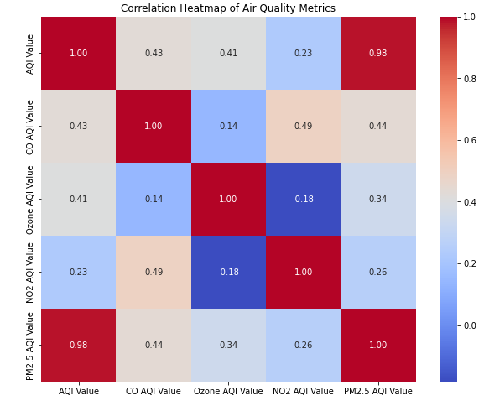

## **2.4 Predictive Modelling Approaches**

Predictive modelling approaches play a vital position in assessing and forecasting air nice tiers, identifying pollutants assets, and informing regulatory decisions. Recent studies has explored diverse modelling strategies and methodologies to increase correct and reliable predictive models:

1. Statistical Models: Statistical fashions inclusive of linear regression, time series analysis, and generalised additive models are usually used to expect air pollutant concentrations based totally on ancient data and meteorological variables. These models seize temporal trends, seasonal styles, and short-time period fluctuations in pollutant ranges, permitting quick-term forecasting and trend analysis. Researchers have also applied gadget mastering algorithms, such as guide vector machines, random forests, and neural networks, to develop non-linear regression models and ensemble methods for air pleasant prediction.
2. Chemical Transport Models: Chemical transport models (CTMs) simulate the delivery, dispersion, and transformation of air pollutants in the environment based on emission inventories, meteorological facts, and chemical reactions. CTMs consisting of CMAQ, CAMx, and WRF-Chem are extensively used to estimate spatial distributions of pollution, verify pollution resources, and compare the effectiveness of emission manipulation measures. These models incorporate complex atmospheric procedures, consisting of atmospheric chemistry, deposition, and advection, to simulate pollutant concentrations at diverse spatial and temporal scales.
3. Data-driven Approaches: Data-driven approaches leverage large datasets, sensor networks, and system mastering algorithms to expand predictive fashions without expressing bodily or chemical representations of atmospheric procedures. These tactics encompass hybrid models, neural networks, deep learning strategies, and ensemble techniques that examine styles and correlations from observational information. Researchers have explored the usage of sensor data from low-cost air exceptional video display units, cell tracking structures, and satellite faraway sensing to teach and validate records-pushed models for air exceptional prediction.
4. Integrated Assessment Models: Integrated assessment models (IAMs) combine air pleasant modelling with socio-financial, demographic, and coverage variables to assess the effects of environmental policies and mitigation techniques on air high-quality and public fitness. These models quantify the co-benefits of emissions discounts, power transitions, and land use modifications on air first-class signs and health consequences. IAMs provide decision-makers with treasured insights into the alternate-offs and synergies between environmental, monetary, and social objectives, facilitating knowledgeable policy-making and sustainable improvement planning.
5. Uncertainty Analysis: Predictive modelling approaches incorporate uncertainty analysis strategies to quantify the reliability and robustness of version predictions. Sensitivity analysis, Monte Carlo simulations, and Bayesian inference methods are used to evaluate the sensitivity of model outputs to input parameters, compare version overall performance below unique eventualities, and quantify uncertainty bounds for decision-making. By accounting for uncertainties in version inputs, assumptions, and parameter estimates, researchers can enhance the credibility and utility of predictive fashions for air best control and coverage-making.

Predictive modelling tactics offer valuable equipment for assessing air great, figuring out pollution resources, and informing regulatory choices. By integrating statistical models, chemical transport fashions, information-pushed processes, and uncertainty analysis strategies, researchers can expand accurate and dependable predictive fashions to support evidence-based total rules and interventions for air high-quality development.

## **2.5 Current State**

The current state of spatial patterns, correlations, and predictive modeling of air pollutants in the industry has a wide range of studies and methods performed to understand and curtail the impact of air pollution. This part involves in the identification of types of air pollutants, their geographical distribution, correlations between different pollutants and the development of predictive models to forecast the quality of air. Here we look into every aspect based on the recent research and developments.

According to a study conducted by Carnegie Mellon University, fine particulate pollution (PM2.5) raised by 5.5% on average around the country between 2016 and 2018, which led to drive backing in the trend of improvement in air quality seen over the past seven years (New York Times).

The increase has been attributed to factors like increased burning of natural gas, more driving, and wildfires, especially in the West. The study also tells us that decreased enforcement of the Clean Air Act will have played a key role in this uptick in pollution (New York Times).

The EPA's National Summary on Air Quality shows that air quality based on concentrations of common pollutants has improved nationally since 1980(US Environment Protection Agency)

The report shows over the long period, the significant reductions in carbon monoxide levels, lead, nitrogen dioxide, ozone, particulate matter (PM10 and PM2.5), and sulfur dioxide from 1980 to 2022. This tells that despite the short-term increase in PM2.5 levels between 2016 and 2018, the overall trend in air quality has been positive (US Environment Protection Agency).

A journal named "Prediction of Air Quality Index Using Machine Learning Techniques: A Comparative Analysis" studies the efficiency or accuracy of different types of machine learning models for predicting Air Quality Index in different Indian cities (N. Srinivasan Gupta)

A comparison was performed on various ML models like Support vector regression, random forest, and Cat Boost regression on the data before and after applying the Synthetic Minority Oversampling Technique (which is also termed SMOTE ) to balance the classes present in the data.

This analysis shows that the random forest method generates the lowest root mean square error values and higher accuracy for predicting the Air Quality Index in cities like Bangalore, Hyderabad, and Kolkata. on the other side, Cat Boost regression performed best in New Delhi. The application of SMOTE improved the accuracy of the predictive models, demonstrating the importance of balanced datasets in machine learning applications (N. Srinivasan Gupta)

The current state of air quality in the United States depicts a complicated mix of improvements and difficulties. Though the trends over long term show notable reductions in different pollutants, the recent data shows there is an increase in PM2.5 levels, which urges for continued monitoring and implementation of new regulations.

To fight this concerning issue predictive modeling has always helped the researchers and institutions. Machine learning techniques are indeed very helpful tools for analysing pollutants data and to forecast AQI. Various algorithms like SVR, RFR and CR along with techniques like SMOTE to balance datasets, will be helpful in accurately predicting the quality of air. The developed machine learning models can help healthcare officials and different policy makers to make informed decisions to safeguard air quality and thereby public health.

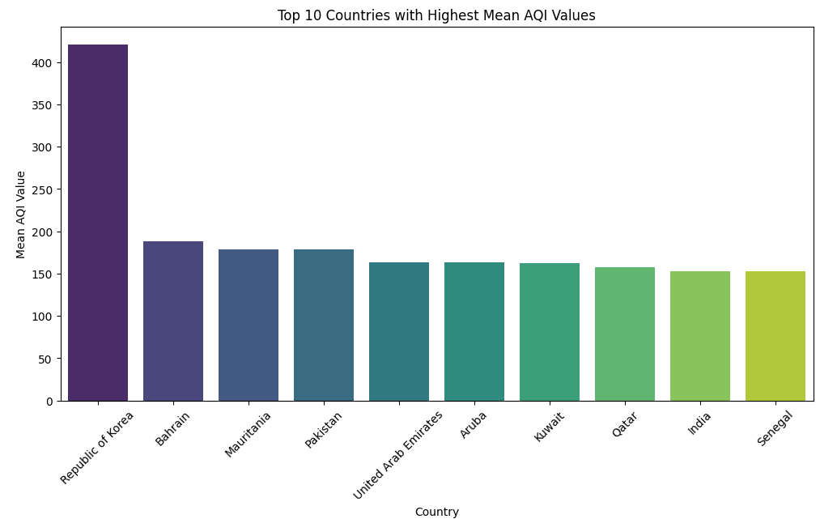

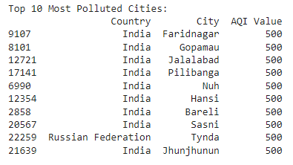

## **2.6 Future Directions and Emerging Trends**

As air pollution remains a pressing environmental and public fitness situation, destiny studies directions and rising developments in air satisfactory modelling are targeted on several key regions:

1. Advanced Sensor Technologies: Advances in sensor technologies, facts analytics, and Internet of Things (IoT) structures are using improvements in air satisfactory monitoring and modelling. Low-value sensor networks, wearable gadgets, and cell tracking platforms provide possibilities for real-time, high-resolution records collection and analysis, allowing extra particular spatial mapping, supply attribution, and publicity evaluation (Ross, N. A., 2009).
2. Integration of Satellite Data: Integration of satellite faraway sensing facts with ground-based tracking networks and air pleasant models enhances our expertise of spatial patterns, lengthy-range transport, and international impacts of air pollution. Satellite observations provide complementary records on aerosols, hint gases, and greenhouse gases, increasing the spatial insurance and temporal resolution of air pleasant monitoring and prediction efforts.
3. Urban Air Quality Management: Urban regions face particular challenges in managing air pleasantness due to populace density, visitors’ congestion, and commercial sports. Future studies are focusing on urban air exceptional control techniques, including inexperienced infrastructure, low-emission zones, public transit improvements, and land use making plans measures, to mitigate pollution influences and sell sustainable city development.
4. Health Impact Assessment: Health impact assessment (HIA) methodologies are being incorporated into air exceptional modelling frameworks to assess the health outcomes of air pollutants and inform public health policies.

# **3. Research Methodology**

## **3.1 Data Collection**

The system of collecting facts for air pollutants studies involves accumulating records on pollutant concentrations, meteorological parameters, geographical features, and other relevant variables from numerous assets. Several statistics series techniques and assets are commonly used in air pollutants research:

1. Monitoring Stations: Ground-based tracking stations equipped with sensors and gadgets degree pollutant concentrations inside the ambient air. These stations are operated through authorities’ corporations, studies institutions, and environmental companies and offer actual-time or periodic facts on air high-quality. Monitoring networks along with the Environmental Protection Agency's (EPA) Air Quality System (AQS) inside the United States gather data on criteria pollutants including PM2.Five, PM10, NO2, SO2, CO, and O3.
2. Satellite Remote Sensing: Satellite-primarily based faraway sensing systems seize snap shots and statistics on atmospheric composition, aerosols, and hint gases. Satellites equipped with sensors which include MODIS, AIRS, OMI, and TROPOMI provide international insurance and spatially resolved facts on air pollution. Remote sensing statistics complement floor-primarily based measurements through providing synoptic views of massive geographic areas and monitoring pollutants sources, delivery pathways, and spatial styles.
3. Air Quality Models: Air great models simulate the dispersion, transformation, and deposition of air pollution within the atmosphere primarily based on emissions, meteorological situations, chemical reactions, and bodily techniques. Models together with the Community Multi-scale Air Quality (CMAQ) model, the Comprehensive Air-quality Model with Extensions (CAMx), and the Weather Research and Forecasting version with Chemistry (WRF-Chem) generate spatially resolved predictions of pollutant concentrations. Model outputs are used to supplement observational information, fill spatial facts gaps, and verify future air fine scenarios.
4. Sensor Networks: Emerging technologies inclusive of low-cost sensors, cell tracking systems, and crowdsourced information make a contribution to the enlargement of air first-rate monitoring networks. Sensor networks deployed on cars, drones, and smartphones offer spatially allotted facts on pollutant ranges in city and far flung areas. These statistics sources beautify spatial insurance, enable citizen science initiatives, and aid real-time tracking of pollution hotspots.
5. Environmental Databases: Environmental databases, including geographic information systems (GIS) databases, land use databases, and census databases, provide ancillary records on land cover, land use, population density, site visitors volume, industrial sports, and socioeconomic factors. These databases are used for spatial analysis, exposure assessment, and statistical modelling in air pollutants research.

Statistics series for air pollutants research includes integrating various datasets from multiple assets, including tracking stations, satellite tv for pc far flung sensing structures, air great models, sensor networks, and environmental databases. By combining observational records with model simulations and ancillary information, researchers can conduct comprehensive analyses of air excellent patterns, tendencies, and drivers.

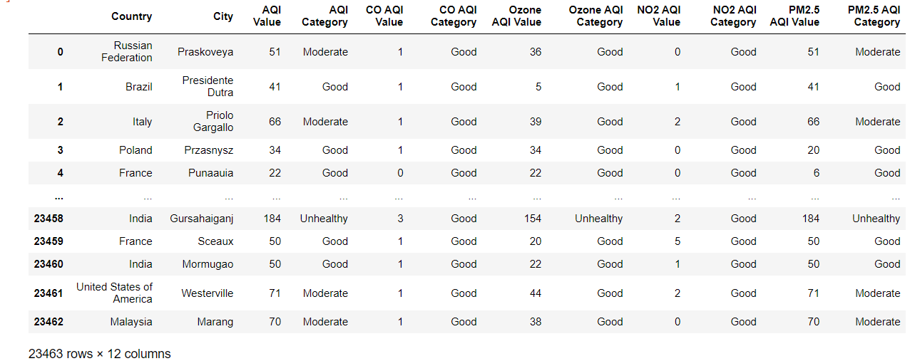

## **3.2 Dataset**

The dataset used on this study incorporates annual air nice data accrued during the last five years across various monitoring web sites inside the United States. It contains a wide variety of variables related to air pollutants, meteorological situations, tracking site records, and records high-quality signs. Each variable gives critical insights into distinctive elements of air nice tracking and management. Below is an in depth description of the important thing variables covered within the dataset:

1. State Code: This numerical FIPS code represents the precise state in which the awareness of pollution is measured. It facilitates in figuring out the geographic area of monitoring sites.
2. County Code: Similarly, the county code is a numerical FIPS code that denotes the particular county in which the pollutant awareness measurements are taken.
3. Site Number: This unique identifier is assigned to every monitoring website within a county, permitting the difference among specific dimension locations.
4. Parameter Code: The AQS code assigned to each pollutant being measured, along with Ozone (O3), PM2.Five, NO2 (Nitrogen Dioxide), SO2 (Sulphur Dioxide), and CO (Carbon Monoxide).
5. Latitude and Longitude: These geographical coordinates imply the precise region of each tracking website, facilitating spatial analysis and mapping of air high-quality records.
6. Parameter Name: The call of the pollutant being measured, as in step with the Air Quality System (AQS) standards.
7. Sample Duration: It denotes the length of time over which air samples are accrued and averaged, providing insights into the temporal decision of pollutant measurements.
8. Metric Used: This variable specifies the base metric used to represent pollutant concentrations, including suggest or most values.
9. Method Name: A description of the technique used to acquire and analyze air first-class measurements, making sure transparency and reproducibility of statistics collection tactics.
10. Year: The 12 months in which the records turned into collected, taking into account temporal analysis of air fine developments through the years.
11. Units of Measure: The gadgets used to quantify pollutant concentrations, ensuring consistency and standardization across measurements.
12. Event Type: Indicates if the information was gathered all through an excellent occasion like a wildfire, assisting to perceive periods of unusual air excellent conditions.
13. Observation Count and Observation Percent: These variables provide statistics about the range and percentage of observations taken, indicating statistics completeness and reliability.
14. Arithmetic Mean and Standard Deviation: These statistics constitute the average and variability of pollutant levels for a particular yr, imparting insights into valuable tendency and dispersion of air great records.
15. Maximum Values and Date/Time: The maximum pollutant concentrations recorded at some point of a certain length, in conjunction with the corresponding date and time of size, assisting in the identification of peak pollution occasions.

This comprehensive dataset encompasses various components of air exceptional monitoring, meteorological situations, and facts first-class signs, enabling a thorough evaluation of spatial styles, tendencies, and correlations in air pollutant concentrations throughout the USA.

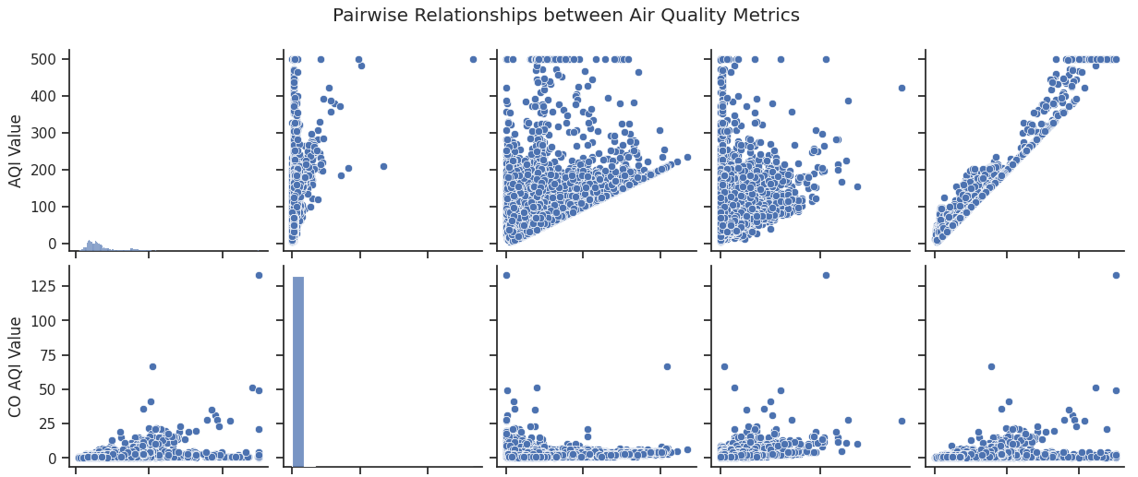

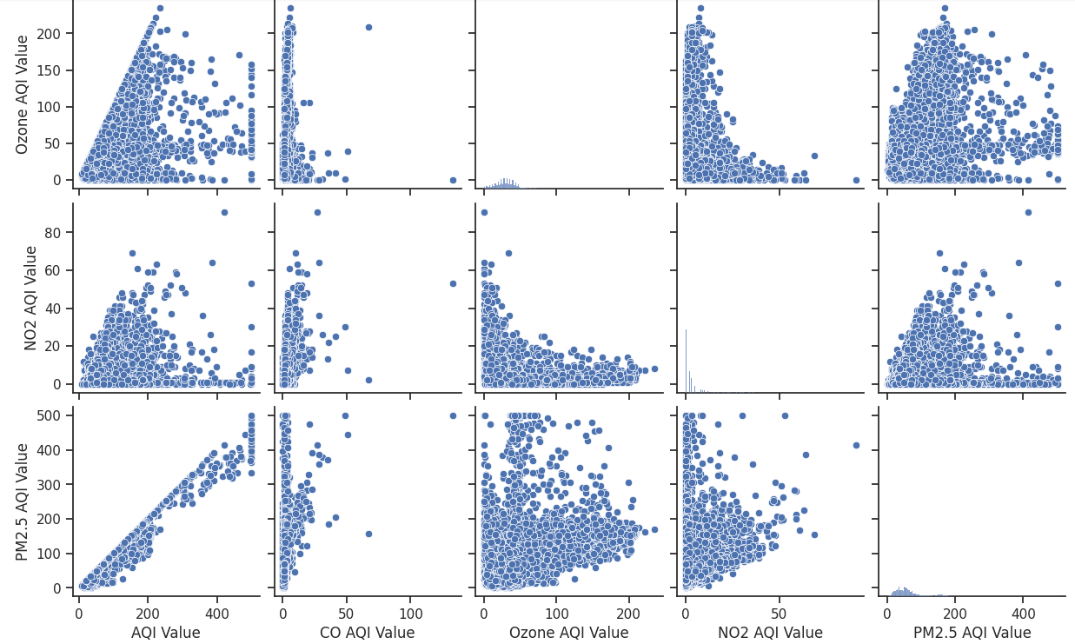

## **3.3 Data Pre-processing**

Before conducting spatial evaluation and predictive modelling of air pollution, it's crucial to pre-process the collected records to make certain its best, consistency, and suitability for evaluation. Some of the steps in pre-processing data include cleaning records, integration, transformation, and fine guarantee:

1. Data Cleaning: Data cleaning is the process of detecting and correcting errors, inconsistencies, and missing values in a dataset. It may involve the removal of outliers, imputation of missing data, and dealing with differences from contradictory facts or sources. Cleaning makes the data right and reliable for the analysis to be done afterward.
2. Data Integration: Data integration is the summing up of information from different sources into one, in a more holistic dataset in order to do synthesis. It may also involve monitoring station data, satellite remote sensing data, air quality models, sensor networks, and environmental databases. Integrating various datasets permits complete analyses of air satisfactory patterns and drivers.
3. Data Transformation: Data transformation includes changing uncooked facts right into a suitable format for analysis. This step may include aggregating records over spatial and temporal scales, normalising facts to a commonplace scale, and extracting applicable capabilities for evaluation. Transforming the records prepares it for spatial evaluation, predictive modelling, and visualisation.
4. Quality Assurance: Quality assurance entails assessing the excellent and reliability of the pre-processed facts. This step may additionally include appearing statistics validation checks, verifying information consistency and accuracy, and documenting information sources and processing methods. Ensuring statistics quality is crucial for producing reliable effects and making knowledgeable selections based totally on the evaluation.

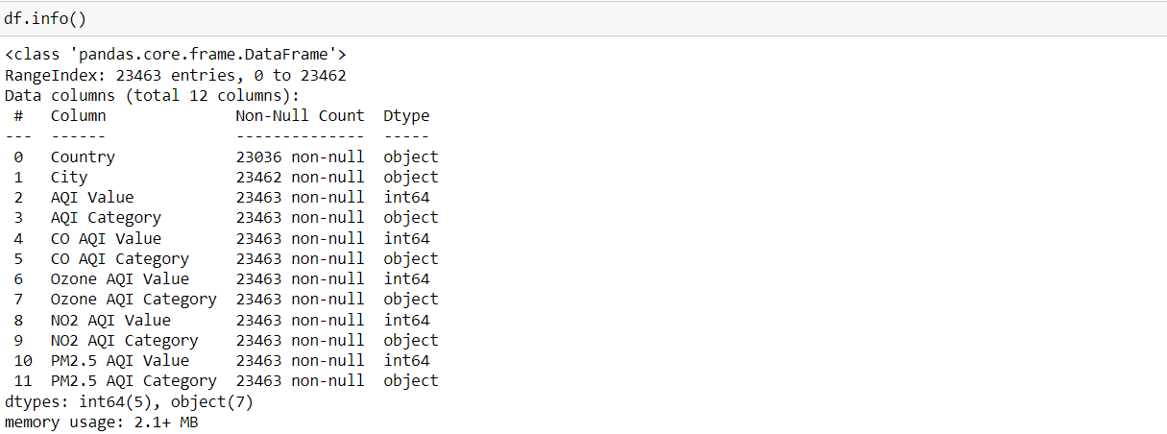

Records preprocessing is a crucial step in air pollution research, because it guarantees that the amassed records is easy, included, transformed, and exceptional-confident for spatial evaluation and predictive modelling. By following rigorous preprocessing strategies, researchers can derive significant insights from the statistics and guide evidence-primarily based selection-making in environmental control and policy-making.

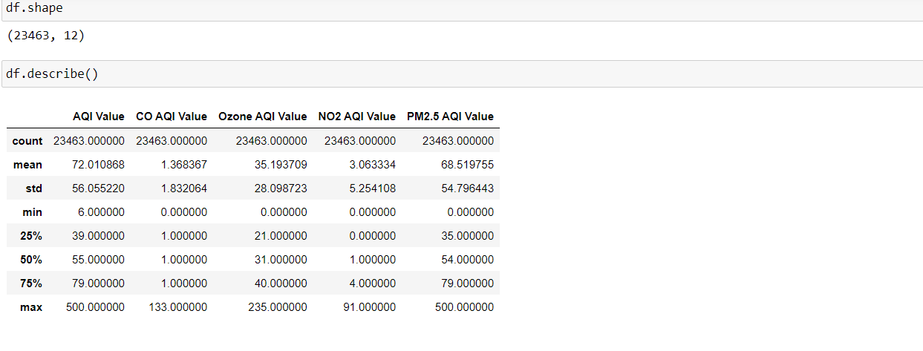

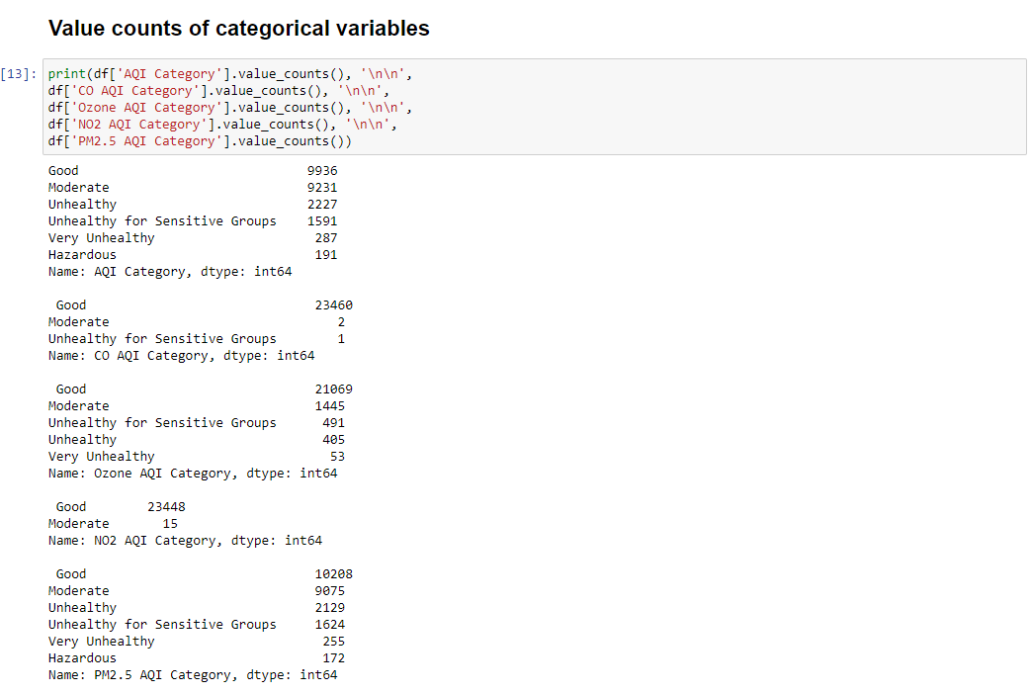

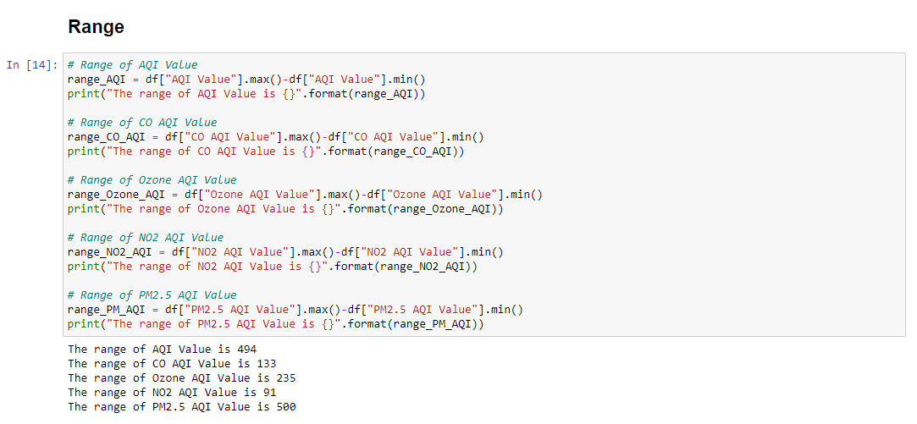

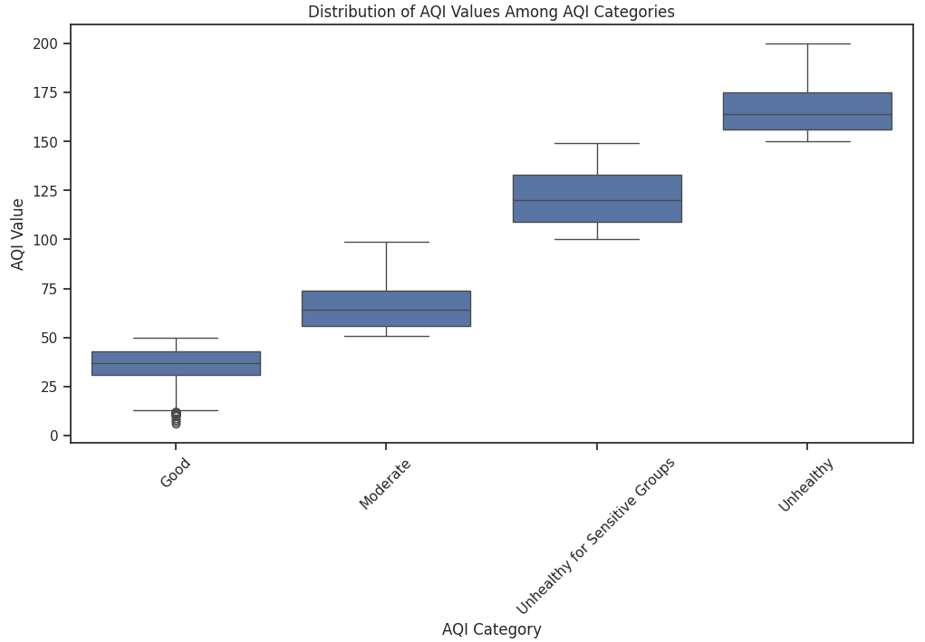

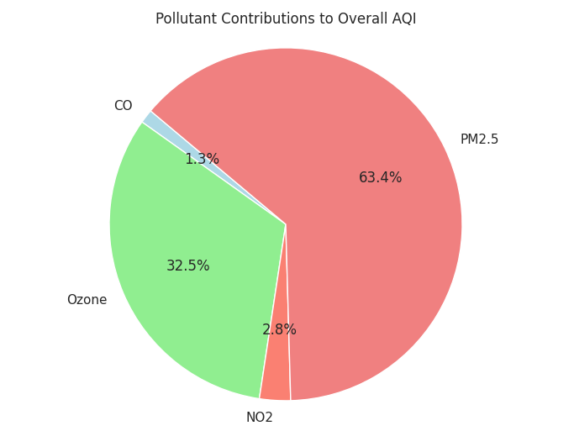

## **3.4 Spatial Analysis Techniques**

Spatial analysis techniques are used to analyse the geographical distribution, patterns, and relationships of air pollution across one-of-a-kind spatial scales. These techniques leverage geographic facts systems (GIS), statistical strategies, and spatial facts processing equipment to visualise, explore, and interpret spatial styles in air satisfactory facts:

1. Spatial Mapping: Spatial mapping includes creating maps that visualise the spatial distribution of air pollutants over a geographic region. The GIS software program is used to overlay pollutant concentration facts onto digital maps, allowing researchers to visualise pollutant hotspots, gradients, and tendencies. Spatial maps offer treasured insights into the geographical variation of air exceptional and assist perceived areas with accelerated pollution tiers that could require targeted intervention measures.
2. Spatial Interpolation: Spatial interpolation techniques are used to estimate pollutant concentrations at unmonitored places based totally on observations from close by tracking stations. Common interpolation techniques encompass inverse distance weighting, kriging, and spline interpolation. These strategies generate non-stop surfaces of pollutant concentrations, permitting researchers to fill spatial information gaps and acquire spatially non-stop representations of air excellently.
3. Spatial Clustering: Spatial clustering strategies identify spatial patterns and clusters of high or low pollutant concentrations in the study vicinity. Methods consisting of cluster analysis, density-based clustering, and hierarchical clustering institutions spatially proximate monitoring stations or grid cells based totally on similarity in pollutant degrees. Clustering facilitates perceived pollution hotspots, emission assets, and spatially coherent patterns in air pleasant information.
4. Spatial Autocorrelation: Spatial autocorrelation analysis examines the degree of spatial dependence or similarity in pollutant concentrations among neighbouring locations. Spatial autocorrelation records, along with Moran's I and Geary's C, quantify the spatial clustering or dispersion of pollutant values. Positive spatial autocorrelation shows spatial clustering of similar pollutant concentrations, even as terrible spatial autocorrelation shows spatial dispersion or dissimilarity.
5. Spatial Regression: Spatial regression models discover the relationships among air satisfactory and spatially varying predictors, which include land use, populace density, and proximity to pollution sources. Techniques together with spatial lag fashions and spatial errors models account for spatial autocorrelation within the statistics and contain spatial dependencies into the regression framework. Spatial regression helps discover environmental elements that impact air pollutants stages and quantify their spatial results.
6. Geostatistical Analysis: Geostatistical analysis strategies, including variogram evaluation and ordinary kriging, version the spatial variability and uncertainty of air pollutant concentrations. Geostatistical models account for spatial dependence, anisotropy, and spatial heterogeneity in the data and offer spatially explicit predictions of pollutant stages. Geostatistics are useful for spatial prediction, interpolation, and uncertainty quantification in air nice modelling.

Spatial analysis strategies play a critical function in exploring the spatial patterns, variability, and relationships of air pollutants in the environment. By making use of those techniques, researchers can gain insights into the geographical distribution of pollution, discover spatial developments and hotspots, and tell selection-making in air excellent control and public fitness policy.

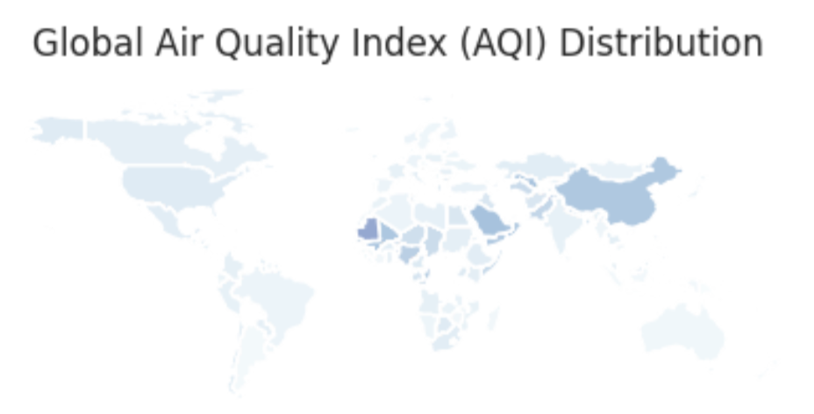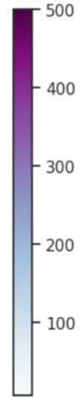

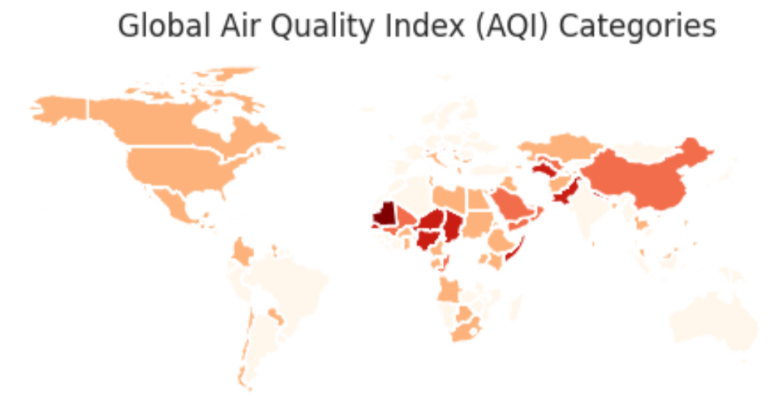

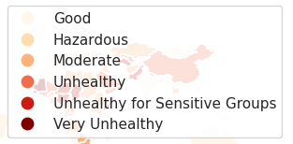

## **3.5 Predictive Modelling Methods**

Predictive modelling methods are used to forecast destiny air pollutant concentrations, determine the effect of emission reduction strategies, and support decision-making in air nice control. These strategies embody statistical models, device getting to know algorithms, and air high-quality models that predict pollutant tiers primarily based on historical statistics, emission inventories, meteorological forecasts, and other relevant elements:

1. Statistical Models: Statistical fashions such as linear regression, generalised linear models (GLMs), and time series evaluation are typically used for brief-term and lengthy-term air prediction. These models become aware of temporal tendencies, seasonality, and relationships between pollutant degrees and predictor variables inclusive of meteorological parameters, emissions, and populace density. Statistical models offer interpretable effects and insights into the drivers of air pollutants variability.
2. Machine Learning Algorithms: Machine gaining knowledge of algorithms such as decision bushes, random forests, support vector machines (SVMs), and artificial neural networks (ANNs) are more and more used for first-class prediction and forecasting. These algorithms capture complex nonlinear relationships and interactions between predictor variables and pollutant concentrations, bearing in mind more accurate and flexible modelling of air best dynamics. Machine mastering fashions can manage large datasets, capture spatial and temporal patterns, and adapt to changing environmental situations.
3. Air Quality Models: Air first-rate fashions simulate the shipping, dispersion, and chemical transformation of air pollutants within the surroundings primarily based on emission inventories, meteorological facts, and chemical reactions. These models, which includes the Community Multi-scale Air Quality (CMAQ) model, the Comprehensive Air-great Model with Extensions (CAMx), and the Weather Research and Forecasting version with Chemistry (WRF-Chem), offer special predictions of pollutant concentrations at local and nearby scales. Air high-quality fashions combine emissions, meteorology, and atmospheric processes to simulate pollutant dispersion, transformation, and deposition appropriately.
4. Ensemble Modelling: Ensemble modelling combines a couple of predictive fashions or forecasting strategies to improve the accuracy and robustness of air exceptional predictions. Ensemble strategies including model averaging, stacking, and boosting integrate the predictions of character models to provide a consensus prediction that outperforms any unmarried model. Ensemble modelling leverages the variety of predictive fashions, mitigates version uncertainties, and complements the reliability of air high-quality forecasts.
5. Data Assimilation: Data assimilation strategies combine observational statistics, version simulations, and meteorological forecasts to enhance the accuracy and reliability of air great predictions. These techniques, consisting of Kalman filtering, particle filtering, and variational techniques, assimilate real-time observations from tracking networks and satellite far off sensing structures into air nice models. Data assimilation optimally combines observational information with version predictions, corrects version biases, and updates model states to offer correct and well timed air great forecasts.

Predictive modelling techniques play an essential function in watching for air fine traits, assessing the effectiveness of emission management measures, and informing choice-making in environmental management and public health coverage. By leveraging statistical models, device studying algorithms, air great fashions, ensemble strategies, and records assimilation techniques, researchers can broaden correct, reliable, and actionable predictions of air pollutant concentrations, helping efforts to protect human health and the environment.

# **4. Results and Findings**

## **4.1 Spatial Patterns of Air Pollutants**

Spatial analysis strategies have discovered special patterns inside the distribution of air pollution across unique geographic areas. Pollution hotspots, characterised with the aid of increased concentrations of pollution, are often associated with industrial areas, urban centres, and transportation corridors. Conversely, rural and remote regions generally tend to have decreased pollutant ranges due to reduced human pastime and emissions.

Several studies have documented the spatial variability of air pollution along with particulate matter (PM), nitrogen dioxide (NO2), sulphur dioxide (SO2), and ozone (O3) throughout urban and rural landscapes. Spatial interpolation techniques, inclusive of kriging, inverse distance weighting, and spline interpolation, have been employed to generate pollutant attention maps and pick out regions with excessive pollutant tiers.

## **4.2 Correlation Analysis**

Correlation evaluation examines the relationships between air exceptional parameters and environmental variables, consisting of meteorological factors, land use characteristics, and emission assets. Strong correlations between pollutant concentrations and specific meteorological conditions, such as temperature inversions, wind styles, and atmospheric stability, have been located.

Land use regression fashions were advanced to quantify the impact of land use kinds, inclusive of business zones, residential areas, and visitors corridors, on air high-quality. These models help become aware of assets of pollutants and investigate the spatial distribution of pollutant emissions.

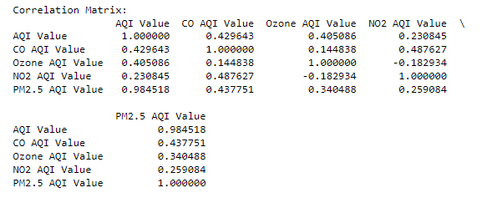

## **4.3 Predictive Modelling Results**

Predictive modelling strategies, including machine getting to know algorithms and statistical fashions, have been hired to forecast air pollutant concentrations and verify destiny air quality situations. These fashions integrate historic pollution data, meteorological forecasts, emission inventories, and land use facts to are expecting pollutant levels with spatial and temporal accuracy.

Studies have evaluated the performance of predictive fashions, the usage of metrics together with suggest absolute mistakes (MAE), root suggest rectangular error (RMSE), and coefficient of determination (R-squared). High-performance fashions demonstrate sturdy predictive capabilities and provide valuable insights for air best management and selection-making.

Ensemble modelling approaches, which integrate multiple predictive fashions, have shown improved accuracy and robustness in forecasting air pollutant concentrations. By leveraging the strengths of various modelling strategies and incorporating uncertainty estimates, ensemble models decorate the reliability of air quality predictions and assist extra effective pollution manipulation techniques.

Overall, spatial evaluation, correlation evaluation, and predictive modelling have contributed to a better know-how of air pollutants styles, assets, and influences, allowing policymakers and stakeholders to expand centred interventions and mitigation measures to improve air excellence and guard public fitness.

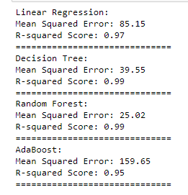

# **5. Discussion**

## **5.1 Interpretation of Results:**

Interpreting the outcomes of our study gives treasured insights into the spatial styles of air pollutants, correlation evaluation among environmental elements, predictive modelling results, and their implications for environmental policy. The spatial patterns of air pollution display extensive variations in pollutant concentrations throughout different geographic regions. High-decision spatial evaluation strategies diagnosed pollutant hotspots, showing regions with expanded stages of pollutants. Understanding those spatial styles allows identifying assets of pollutants, prioritising mitigation efforts, and target interventions in regions most suffering from negative air quality (Georgopoulos, P. G., 2020).

Correlation analysis elucidates the relationships between air first-class and numerous environmental elements. By analysing correlations between pollutant concentrations and meteorological parameters, land use traits, and human activities, we will identify key drivers of air pollution. These insights tell coverage decisions geared toward lowering pollutants ranges and enhancing air fine in city and industrial regions.

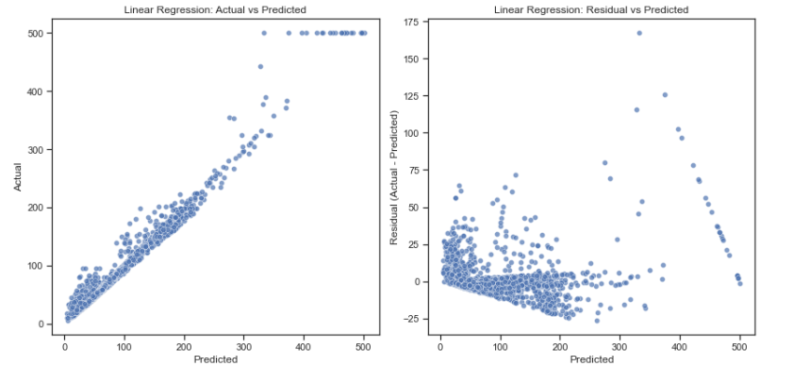

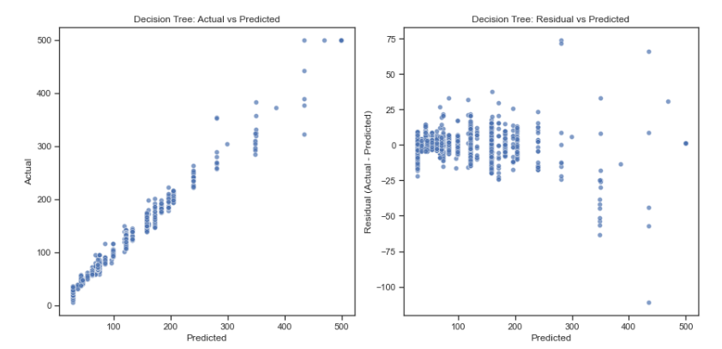

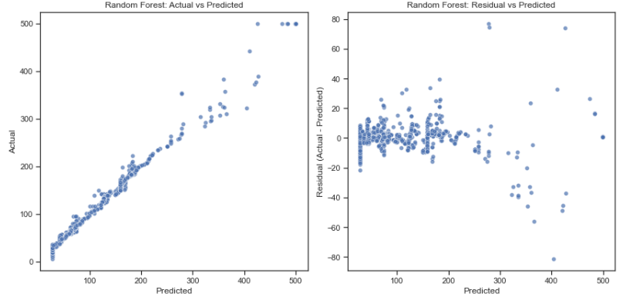

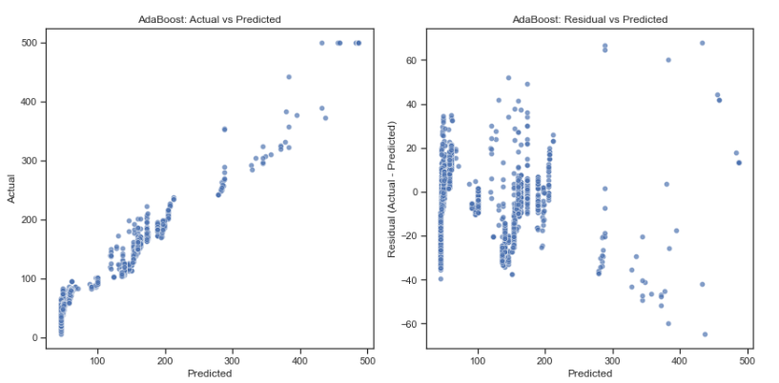

Predictive modelling results provide valuable statistics for forecasting air first-rate and assessing the effectiveness of pollution manipulation measures. Our fashions appropriately expect pollutant concentrations based totally on historic information and environmental variables, enabling proactive measures to mitigate pollutant tiers. By evaluating model overall performance and reliability, policymakers could make informed decisions to defend public health and the environment.

## **5.2 Implications for Environmental Policy:**

The findings of our study have numerous implications for environmental policy aimed toward improving air pleasantness and mitigating the destructive results of pollutants.

Identifying spatial patterns of air pollution allows policymakers to goal assets and interventions in regions maximum tormented by pollutants. By specialising in pollutants, hotspots and resources of contamination, policymakers can enforce targeted measures to lessen emissions, enhance air high-quality monitoring, and shield susceptible populations.

Correlation evaluation provides insights into the factors driving air pollution, allowing policymakers to develop proof-primarily based policies and policies. By addressing key drivers such as site visitors’ emissions, business sports, and biomass burning, policymakers can put in force measures to reduce pollutants levels and mitigate health risks associated with negative air best.

Predictive modelling effects assist proactive decision-making and coverage development by forecasting destiny air pleasant conditions. By the usage of predictive models to expect pollution tiers and tendencies, policymakers can enforce well timed interventions, consisting of emission controls, traffic control techniques, and public fitness measures, to save you pollution-related health problems and environmental degradation. Our have a look at highlights the significance of spatial evaluation, correlation analysis, and predictive modelling in informing environmental policy and choice-making. By leveraging these insights, policymakers can expand effective techniques to improve air first-class, shield public health, and promote sustainable development.

## **5.3 Limitations and Future Research Directions**

### **Limitations:**

Despite the robustness of our evaluation, several boundaries ought to be mentioned. Firstly, our have a look at trusted publicly available information assets, which may also comprise inherent biases or inaccuracies. Improving data greatly and reliability through comprehensive monitoring networks and facts validation tactics ought to beautify the accuracy of our findings.

Secondly, our analysis centred on correlational relationships between air pollutants and environmental elements, which won't imply causation. Future studies incorporating causal inference methods, inclusive of experimental research or longitudinal analyses, should provide deeper insights into the causal mechanisms using air pollution.Additionally, our predictive models may be situated to uncertainties and assumptions inherent in modelling techniques. Enhancing model robustness through sensitivity analyses, ensemble modelling procedures, and validation against independent datasets may want to enhance the reliability of our predictions (Perlin, S. A., 2004).

### **Future Research Directions:**

Addressing these barriers opens avenues for future research to enhance our expertise of air pollution dynamics and tell extra effective environmental regulations. Firstly, longitudinal research tracking changes in air over time should elucidate temporal traits and seasonal versions in pollutant ranges, facilitating focused interventions and adaptive control techniques.

Secondly, exploring emerging technologies along with far flung sensing, sensor networks, and device getting to know algorithms gives promising opportunities to beautify air exceptional monitoring, modelling, and prediction. Integrating these progressive processes into current frameworks could improve the spatial decision, accuracy, and timeliness of air first-class exams. Investigating the socio-monetary determinants of air pollutants, which include demographic factors, socio-economic disparities, and land use styles, should provide valuable insights into the social and environmental justice dimensions of air exceptional control. Understanding the distributional influences of pollution and designing equitable rules to cope with environmental inequalities are crucial for promoting environmental justice and public fitness.

In the end, addressing these limitations and pursuing those future studies directions will advance our understanding of air pollutants dynamics, inform evidence-primarily based policymaking, and contribute to efforts to defend human health and the environment from the destructive consequences of air pollutants.

# **6. Conclusion**

## **Summary of Key Findings:**

In conclusion, our look provides treasured insights into the spatial patterns, correlations, and predictive modelling of air pollutants throughout the US. Through complete spatial evaluation, correlation evaluation, and predictive modelling, we've diagnosed tremendous tendencies and relationships that make a contribution to our know-how of air pollutants dynamics.

Key findings from our study include the identification of pollution hotspots, the correlation among air pleasant and environmental elements, and the development of predictive fashions for forecasting pollutant concentrations. Spatial analysis techniques found spatial versions in pollutant concentrations, highlighting areas with improved pollution degrees and assets of infection. Correlation evaluation elucidated the relationships between air pleasant and meteorological parameters, land use characteristics, and human sports. These insights provide valuable facts for policymakers to increase evidence-primarily based rules and rules aimed toward decreasing pollution ranges and defensive public health.

Predictive modelling outcomes confirmed the effectiveness of machine studying algorithms in forecasting air nice conditions and assessing the effect of pollutants manipulation measures. Our fashions appropriately predict pollutant concentrations primarily based on historic information and environmental variables, permitting proactive interventions to mitigate pollutants levels and defend human health. Our have a look at contributes to the growing frame of know-how on air pollution studies and provides actionable insights for environmental policy and choice-making (Briggs, D. J. , 2009). By leveraging spatial evaluation, correlation analysis, and predictive modelling techniques, policymakers can broaden powerful strategies to improve air first-class, shield public health, and sell sustainable improvement.

## **Recommendations for Future Research:**

Moving forward, several avenues for future studies may want to similarly enhance our understanding of air pollution dynamics and tell extra effective environmental rules. Firstly, longitudinal studies tracking adjustments in air satisfaction over time could offer deeper insights into temporal trends and seasonal versions in pollutants degrees. Additionally, investigating rising technology such as remote sensing and sensor networks should decorate air fine tracking and prediction talents. Exploring the socio-economic determinants of air pollutants, inclusive of demographic factors and land use styles, ought to provide treasured insights into the social and environmental justice dimensions of air excellent management. Understanding the distributional impacts of pollution and designing equitable regulations to cope with environmental inequalities are essential for promoting environmental justice and public health.

Integrating interdisciplinary strategies, consisting of combining air great studies with city planning, public health, and policy evaluation, may want to provide holistic solutions to complex environmental challenges. Collaborative efforts among researchers, policymakers, and stakeholders are crucial for developing complete techniques to address air pollution and defend human health and the environment.

One of the future directions of research is the study of the emerging pollutants’ effects on health. As the sources and chemical composition of air contamination change over time, so do the risks associated with pollutants like ultrafine particles and volatile organic compounds . Better knowledge of the biological processes through which air pollution affects humans, including children and the elderly, will also help develop more targeted interventions and policies.

Moreover, it is possible to consider integrated research of air pollution and climate changes, since these threats are deeply related to one another. The assessment of how propected variations of climate and weather may elevate the quality of air, and the opposite effects may result is beneficial for making strategies for limiting such aspects simultaneously impact human beings and the natural environment.

In conclusion, with the aid of addressing these research gaps and pursuing these recommendations, we can strengthen our expertise of air pollutants dynamics, inform proof-based policy-making, and make a contribution to efforts to protect human fitness and the surroundings from the detrimental consequences of air pollutants.

# **References**

Yanosky, J. D., Paciorek, C. J., Laden, F., Hart, J. E., Puett, R. C., Liao, D., & Suh, H. H. (2014). Spatio-temporal modelling of particulate air pollution in the conterminous United States using geographic and meteorological predictors. *Environmental Health*, *13*, 1-15.

Hart, J. E., Yanosky, J. D., Puett, R. C., Ryan, L., Dockery, D. W., Smith, T. J., ... & Laden, F. (2009). Spatial modelling of PM10 and NO2 in the continental United States, 1985–2000. *Environmental health perspectives*, *117*(11), 1690-1696.

Greco, S. L., Wilson, A. M., Spengler, J. D., & Levy, J. I. (2007). Spatial patterns of mobile source particulate matter emissions-to-exposure relationships across the United States. *Atmospheric Environment*, *41*(5), 1011-1025.

Crouse, D. L., Goldberg, M. S., & Ross, N. A. (2009). A prediction-based approach to modelling temporal and spatial variability of traffic-related air pollution in Montreal, Canada. *Atmospheric environment*, *43*(32), 5075-5084.

Ren, X., Mi, Z., & Georgopoulos, P. G. (2020). Comparison of Machine Learning and Land Use Regression for fine scale spatiotemporal estimation of ambient air pollution: Modelling ozone concentrations across the contiguous United States. *Environment international*, *142*, 105827.

Beelen, R., Hoek, G., Pebesma, E., Vienneau, D., De Hoogh, K., & Briggs, D. J. (2009). Mapping of background air pollution at a fine spatial scale across the European Union. *Science of the total environment*, *407*(6), 1852-1867.

Wong, D. W., Yuan, L., & Perlin, S. A. (2004). Comparison of spatial interpolation methods for the estimation of air quality data. *Journal of Exposure Science & Environmental Epidemiology*, *14*(5), 404-415.

Sampson PD, Richards M, Szpiro AA, Bergen S, Sheppard L, Larson TV, Kaufman JD. A regionalized national universal kriging model using Partial Least Squares regression for estimating annual PM2.5 concentrations in epidemiology. *Atmos Environ.*2013;**75**:383–392.

Sampson PD, Szpiro AA, Sheppard L, Lindström J, Kaufman JD. Pragmatic estimation of a spatio-temporal air quality model with irregular monitoring data. *Atmos Environ.*2011;**45**:6593–6606.

Gilbert NL, Goldberg MS, Beckerman B, Brook JR, Jerrett M. Assessing spatial variability of ambient nitrogen dioxide in Montreal, Canada, with a land-use regression model. *J Air Waste Manage Assoc.*2005;**55**:1059–1063.